

V 1.2
June 2026
XStep Design Specification
SMPL: Component Goods Issue

Table of Contents
1 Purpose 3
2 Overview 3
3 Reasons for developing 4
4 Authorization 5
5 Assumptions/ Dependencies 5
6 Validation Checks 5
7 Configuration Specification 5
8 XStep Layout Design 6
9 Function Module(s) 7
10 Pseudocode 9
11 Test Scenarios 16
12 Revision History 19

Purpose
This document outlines the design, along with the configuration specifications for the XStep “SMPL: Component Goods Issue”.

Overview
The Component Goods Issued XStep facilitates and records the issuing of components from inventory to a process order. This step ensures that all materials used during manufacturing are accounted for in compliance with Good Manufacturing Practice (GMP) and traceability requirements.
This step is integrated with the SAP Data Master. The functionality supports various phases of manufacturing by enabling the selection of various materials.
This XStep includes the following functional coverage:
- Manual entry of component materials and batches required for the current process order.
- Automated posting of the goods issue against the process order.
- Data validation for correct material, batch and quantity entries.
- Ensuring traceability and compliance with inventory and production reconciliation standards.
The XStep contains two main input parameters:
- IV_HEADER - This can be changed in SiMPL MBR to display specific header text for the XStep
- IV_INSTR - This can be changed in SiMPL MBR to display a specific set of instructions for the XStep that will be displayed below the header
- IV_TABLTIT - This can be changed in SiMPL MBR to display specific table header text for the XStep
- IV_STG_LOC – This can be changed to indicate the Storage Location for material consumption. The parameter is by default set to “0010” for AZGPF.
- IV_SIGN – This can be changed in SiMPL MBR to author standalone signatures as part of the xstep.
The operator enters the Material No, Batch No, Serial Number (Optional field) & Quantity:
- “Material Number” - Input
- “Batch” - Input
- “Serial Number” - Input
- “Qty” - Input
- “Scrap Qty.” - Input
- “UoM” - Input
- “Supervisor Signature” - Input
The function module /SMPL/PPPI_FM_GI_SETUP_LINE verifies the material nr against the Master Data retrieves the following information:
- “#” - Output
- “Description” - Output
The function module ZSMPL_FM_GET_EXPIRY verifies the material nr and the batch against the Master Data and retrieves the following information related to the material/batch:
- “Exp. Date” - Output

For variant two, the operator selects from the “Goods Issue Required?” dropdown if unplanned goods issue is required or not:
- Goods Issue Required? - Input Dropdown
Functional Design
Two variants of the same SMPL: Component Goods Issue XStep include:
Variant 1: Standard Goods Issue
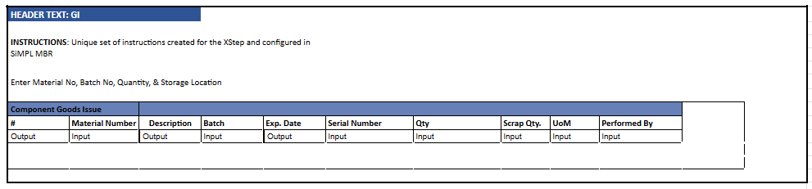
Variant 2: Unplanned Goods Issue
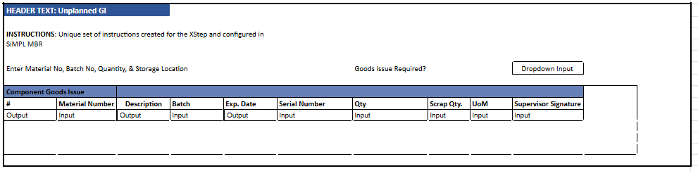

Reasons for developing
The development of the SMPL: Component Goods Issue XStep is required to:
- Automate the goods issue process directly within the batch record to ensure that component consumption is posted accurately and in real time.
- Capture batch numbers, quantities, and storage locations electronically to support full traceability.
- Integrate the goods issue step into the production process to simplify the operator workflow by guiding them through required material movements within the same electronic record, reducing reliance on separate inventory transactions or paperwork.

Authorization
N/A

Assumptions/ Dependencies
 | Assumption
1 | The function module has up-to-date access to material master data stored in the SAP system.
2 | The function module can successfully pull material data into the PI sheet output fields.
3 | Material/batch validation logic is available to prevent incorrect or duplicate entries across goods issue.

Validation Checks
Error Handling
Error | Action
Missing goods issue quantity | The operator must enter a value in the goods issue quantity column for each material line used in the operation.
Goods issue posting failure | Verify process order is valid, released and sufficient stock is available
Duplicate line entry | Remove or merge duplicate lines to proceed

Configuration Specification
Goods Issue Configuration (Z_PICONS)
The process message Z_PICONS is used to communicate goods issue data from the XStep execution to the backend system. This message handles material consumption postings (typically movement type 261) for the components used in production. During execution, the XStep collects and transfers relevant component data such as material number, batch, issued quantity, unit of measure, storage location, and any applicable scrap quantities. The message is triggered upon confirmation of each goods issue table row and ensures that the component consumption is correctly reflected in the process order. All generated process messages are captured in transaction CO54, where they can be monitored and processed/sent. Configuration of Z_PICONS allows flexible mapping of input parameters and supports integration with both standard and custom logic for inventory updates and traceability.

XStep Layout Design
Variant one:
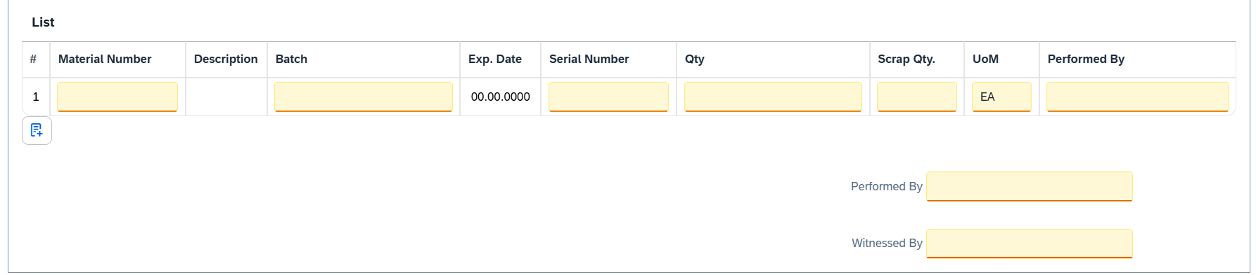
Variant two:
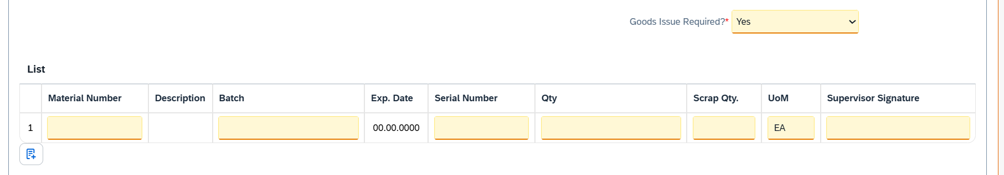

Function Module(s)
Function: /SMPL/PPPI_FM_GI_SETUP
Import Parameters:
Parameter Name | Associated Type | Short Text
IV_WERKS | WERKS_D | N/A
IV_MAT | MATNR | N/A
IV_LGORT | LGORT_D | N/A
IV_UOM | ERFME | N/A

Function: /SMPL/PPPI_FM_SET_LINE_IDX
Export Parameters:
Parameter Name | Associated Type | Short Text
ET_INDEX_T1 | /SMPL/STR_TT_VORNR | Table 1 Index
ET_INDEX_T2 | /SMPL/STR_TT_VORNR | Table 2 Index

Function: /SMPL/PPPI_FM_GI_SETUP_LINE
Import Parameters:
Parameter Name | Associated Type | Short Text
IV_WERKS | WERKS_D | N/A
IV_MAT | MATNR | N/A
IV_DESC | MAKTX | N/A
IIV_LGORT | LGORT_D | N/A
IV_UOM | ERFME | N/A
IV_XCHPF | BOOLE_D | N/A
IV_INDEX | CHAR30 | N/A
IT_INDEX | /SMPL/STR_TT_SHORT_TEXT | Char 30 Table Type

Export Parameters:
Parameter Name | Associated Type | Short Text
EV_MAT | MATNR | N/A
EV_MAT_D | MATNR | N/A
EV_BAT | CHAR30 | N/A
EV_BAT_D | CHAR30 | N/A
EV_BAT_V | CHARG_D | N/A
EV_DESC | CHAR30 | N/A
EV_LGORT | LGORT_D | N/A
EV_LGORT_D | LGORT_D | N/A
EV_UOM | ERFME | N/A
EV_UOM_D | ERFME | N/A

Function: /SMPL/PPPI_FM_INITIAL_ACTIVE
Import Parameters:
Parameter Name | Associated Type | Short Text
IV_ACTIVE | CHAR1 | N/A
Export Parameters:
Parameter Name | Associated Type | Short Text
EV_ACTIVE | CHAR1 | N/A

Function: /SMPL/MBR_DEP_CHECK_ACTIVE
Import Parameters:
Parameter Name | Associated Type | Short Text
IM_CONTROL_RECIPE | POC_DOCID | N/A
IM_PHASE | VORNR
IM_AUFNR | AUFNR
IM_STEP_UUID | /SMPL/MBR_SOG_UUID
IM_PLANT | WERKS_D

Export Parameters:
Parameter Name | Associated Type | Short Text
EV_ACTIVE | CHAR1 | N/A

Exceptions:
Exception | Short Text
CONTROL_RECIPE_INITIAL

Pseudocode
Function: /SMPL/PPPI_FM_GI_SETUP
Purpose
Initializes and standardizes material-related metadata (material number, description, storage location, UOM, and batch indicator) for use in Goods Issue (GI) processing within XSteps or operator workflows. This function determines defaults from master data where values are not already provided.
1. Initialize Material Number
a. If no material is already present in the CV_MAT field:
- Assign IV_MAT → CV_MAT
b. Determine whether the material is batch-managed by querying:
- MARA (general material data)
- MARC (plant-specific material data)
If either has XCHPF = 'X', then:
- Set CV_XCHPF = ABAP_TRUE
2. Fetch Material Description
a. If CV_DESC is initial and CV_MAT is populated:
- Read MAKT table for the material description using:
  - MATNR = CV_MAT
  - SPRAS = SY-LANGU
- Assign result → CV_DESC
Note: Redundant fetch is coded for extra reliability, executed twice for resilience.
3. Determine Storage Location
a. If IV_LGORT is provided:
- Assign IV_LGORT → CV_LGORT
b. Else if CV_LGORT is initial and CV_MAT is populated:
- Read MARC table to get the default production storage location:
  - MATNR = CV_MAT, WERKS = IV_WERKS
- Assign LGPRO → CV_LGORT
4. Assign Unit of Measure
a. If CV_UOM is initial and IV_UOM is provided:
- Assign IV_UOM → CV_UOM
5. Initialize Line Index (for UI Table Mapping)
a. If internal index table CT_INDEX contains at least one row:
- Set the first entry to '1' (usually for UI position indicators or context mapping)
Additional Notes
- Use Case: This function is typically called before operator interaction or automation logic to prefill material-related fields for GI execution.
- Batch Handling: Determines batch relevance automatically, supporting subsequent logic (e.g., for N/A handling or validation in downstream functions).
- Fallback Defaults: Draws from master data (MARA, MARC, MAKT) only when values are not already supplied.
- Index Table (CT_INDEX): Often used to align short texts or item-specific UI elements to logical row positions in the XStep or popup list.
Function: /SMPL/PPPI_FM_SET_LINE_IDX
Purpose
Sequentially assigns index values to entries in an internal table of operation numbers (VORNR), effectively setting or refreshing the table row index for each entry. This is primarily used to maintain positional consistency for downstream processing or display purposes in XSteps or EBR flows.
1. Initialization
- Index Counter:
A local integer variable lv_index is declared and initialized to 1, although it is not used in the final implementation. (Legacy code or planned for future enhancement.)
2. Line Index Assignment
- The function loops over the changing parameter table CT_INDEX using a field symbol.
- Each entry's value is overwritten with the current row number using the system variable sy-tabix.
- Any leading spaces in the resulting string (if the structure is character-type) are removed via SHIFT ... LEFT DELETING LEADING space.
LOOP AT ct_index ASSIGNING FIELD-SYMBOL(<fs_index>).
<fs_index> = sy-tabix.
SHIFT <fs_index> LEFT DELETING LEADING space.
ENDLOOP.
3. Output Parameters
- The final result is written to both export tables:
  - ET_INDEX_T1 (/SMPL/STR_TT_VORNR)
  - ET_INDEX_T2 (/SMPL/STR_TT_VORNR)
- These are returned as copies or references of the updated CT_INDEX.
4. Function Completion
- No exceptions or validations are implemented.
- The function assumes that the input table CT_INDEX is already populated with placeholder values and only updates the line numbers.
- No database operations or lookups are involved, making the function lightweight and fast.
Additional Notes
- Use Case:
Designed for scenarios where table line index values must be explicitly set or refreshed — such as user table input, report line numbering, or step-wise processing of operations in SAP PP-PI.
- Performance:
Efficient due to the simple loop structure and use of native system fields (sy-tabix).
- Dependencies:
None. The function works entirely with internal memory data.
- Limitations:
  - No validation is performed on CT_INDEX content.
  - Entries are treated generically; structure-specific fields are not parsed or analyzed.

Function: /SMPL/PPPI_FM_GI_SETUP_LINE
Purpose
Prepares and standardizes material-related data for use in a Goods Issue (GI) context within an XStep or execution scenario. The function assigns and formats core attributes such as material, batch, storage location, and unit of measure. It also includes logic to suppress batch tracking in non-batch-managed materials.
1. Initialize Material Metadata
a. Assign direct input values to corresponding export fields:
- IV_MAT → EV_MAT, EV_MAT_D
- IV_DESC → EV_DESC
- IV_LGORT → EV_LGORT, EV_LGORT_D
- IV_UOM → EV_UOM, EV_UOM_D
b. Initialize default values for batch fields:
- EV_BAT = ''
- EV_BAT_V = ''
2. Determine Batch Description
a. Apply batch handling logic based on material configuration:
- If material is not batch-managed (IV_XCHPF ≠ ABAP_TRUE) and material number is provided:
  - Set EV_BAT_D = 'N/A' (indicates batch tracking not required)
- Else:
  - Clear EV_BAT_D (to allow future population based on user input or dynamic logic)
3. Output Assignment
a. All key output parameters are now populated and returned to the caller:
- EV_MAT, EV_MAT_D – Material Number (internal and display)
- EV_DESC – Material Description
- EV_LGORT, EV_LGORT_D – Storage Location
- EV_UOM, EV_UOM_D – Unit of Measure
- EV_BAT, EV_BAT_D, EV_BAT_V – Batch (technical, display, and validated fields)
Additional Notes
- Use Case: This function is typically used in line-side GI scenarios where standardization of component parameters is needed before selection, scanning, or posting.
- Batch Management Logic:
Explicitly handles non-batch materials by returning 'N/A' in the batch display field.
Batch validation (EV_BAT_V) is left blank for later processing.
- No External Lookups:
This function does not query master data or perform validations — it simply structures and returns inputs.
- Optional Parameters:
IV_INDEX and IT_INDEX are reserved for indexed material handling (e.g., from a list/table) but are not used in current logic.
Function: /SMPL/PPPI_FM_INITIAL_ACTIVE
1. Initialization
a. Input parameter IV_ACTIVE is optionally provided by the calling logic.
b. Constants gc_yes, gc_no, and gc_inside_range are assumed to be defined globally in the context of the function module.
2. Active Flag Evaluation
a. The function checks if the input value IV_ACTIVE falls within the expected valid range, represented by gc_inside_range.
b. Based on the result:
- If the input value is not equal to gc_inside_range, the XStep is marked as inactive by setting EV_ACTIVE = gc_no.
If the input value is equal to gc_inside_range, the XStep is marked as active by setting EV_ACTIVE = gc_yes.
3. Output Assignment
a. The evaluated result is returned in the EV_ACTIVE export parameter for use by the calling logic (e.g., XStep configuration, PI sheet rendering).
Additional Notes
- This is a simple normalization function that abstracts how activation flags are interpreted for PPPI XSteps
- The use of constants (gc_yes, gc_no, and gc_inside_range) allows the logic to be aligned with broader application settings or standards.
- Helpful in scenarios where input values may vary but need to result in consistent "active" or "inactive" behavior.
- Input is optional, so defaulting behavior can be configured outside this function.
- This function improves clarity and consistency in determining whether an XStep should be active when rendered in the PI Sheet.

Function: /SMPL/MBR_DEP_CHECK_ACTIVE
1. Initialization
a. Input parameters provide context for determining whether an MBR (Manufacturing Batch Record) step can be activated:
- IM_CONTROL_RECIPE (POC_DOCID) – Control recipe ID identifying the batch instruction.
- IM_PHASE (VORNR) (Optional) – Operation or phase within the process order.
- IM_AUFNR (AUFNR) (Optional) – Process order number associated with the step.
- IM_STEP_UUID (/SMPL/MBR_SOG_UUID) – Unique step identifier (SOG).
- IM_PLANT (WERKS_D) – Plant code for process context.
b. The function first validates that IM_CONTROL_RECIPE is not initial.
- If it is initial, the exception CONTROL_RECIPE_INITIAL is raised.
c. Internal data is initialized:
- lt_ord_sigs: Internal table for storing order signature data from /SMPL/MBR_OR_SIG.
- ls_step_dep: Work area for step dependency data.
- Routine LOAD_INTERNAL_DATA is called to populate internal buffers (g_ord_data-t_ord_deps) using IM_AUFNR, IM_CONTROL_RECIPE, and IM_STEP_UUID.
2. Signature Data Retrieval
a. The function retrieves signature records for the process order from database table /SMPL/MBR_OR_SIG.
b. Selected fields include: AUFNR, SOG_UUID, TYPE, CREATED_DATE, CREATED_TIME, DEST_NAME, SIGN_ID, SIGN_DATE, and SIGN_TIME.
c. Only signatures related to the specified order (AUFNR = IM_AUFNR) are selected.
d. These records are stored in the internal table lt_ord_sigs for later evaluation.
3. Dependency Evaluation
a. The function loops through dependencies in g_ord_data-t_ord_deps where:
- TARGET_UUID = IM_STEP_UUID, and
- DEP_RULE is either gc_perform_before_start_rule or gc_verify_before_start_rule.
b. For each dependency record:
- If the rule is PERFORM BEFORE START, it checks whether the prerequisite step (PREREQ_UUID) has a pending perform signature (gc_perform_signature) with SIGN_ID = abap_false.
- If the rule is VERIFY BEFORE START, it checks whether the prerequisite step (PREREQ_UUID) has a pending verify signature (gc_verify_signature) with SIGN_ID = abap_false.
c. If an incomplete signature is found, the step is marked inactive (EV_ACTIVE = gc_step_inactive).
d. If all prerequisite signatures are complete, the step is marked active (EV_ACTIVE = gc_step_active).
4. Output Assignment
a. The evaluated activation status is returned in the export parameter EV_ACTIVE.
- gc_step_active – All prerequisite steps are completed; the current step can start.
- gc_step_inactive – At least one prerequisite step is incomplete; the current step remains blocked.
Additional Notes
This function determines whether a dependent step in a Manufacturing Batch Record is eligible to start based on the completion of prerequisite steps.
Key Features:
- Evaluates Perform Before Start and Verify Before Start dependency rules.
- Dynamically validates signature data from /SMPL/MBR_OR_SIG.
- Integrates with existing MBR dependency structures via global table g_ord_data-t_ord_deps.
Error Handling:
- Raises CONTROL_RECIPE_INITIAL if the control recipe input is missing.
- Handles empty dependency or signature data without runtime errors.
Dependencies:
- Tables: /SMPL/MBR_OR_SIG (Signatures), g_ord_data-t_ord_deps (Step Dependencies).
- Constants: gc_perform_before_start_rule, gc_verify_before_start_rule, gc_perform_signature, gc_verify_signature, gc_step_active, gc_step_inactive.
- Routine: LOAD_INTERNAL_DATA for initializing order context.
Assumptions:
- All prerequisite steps are recorded in the dependency table.
- Signature records are current and synchronized with MBR step progression.
- Activation status is recalculated each time the function is called to reflect live signature data.

Test Scenarios
Variant 1: Component Goods Issue
# | Scenario | Expected Result | Actual Result | Pass/ Fail
1 | Create a Process Order that contains a SMPL: Component Goods Issue | Process Order created containing SMPL: Component Goods Issue | Process Order created containing SMPL: Component Goods Issue
2 | Open the EBR, and navigate to SMPL: Component Goods Issue | The EBR for the selected Process Order and Control Recipe opens successfully without any errors and the SMPL: Component Goods Issue is visible | The EBR for the selected Process Order and Control Recipe opens successfully without any errors and the SMPL: Component Goods Issue is visible
3 | The value entered in parameter IV_HEADER and parameter IV_INSTR in SiMPL MBR appears correctly in the XStep header | Header and instruction text are displayed as authored in SiMPL MBR | Header and instruction text are displayed correctly.
4 | Operator inputs Material Number, Batch, Serial Number, Qty, Scrap Qty., UoM. | Input details are accepted and correct. | Input details are accepted and correct.
5 | Operator verifies that Description and Exp. Date details are populated correctly. | Output details are populated correctly. | Output details are populated correctly.
6 | Enter a username in the “Performed By” field then enter the password in the pop-up window. | Signature is accepted | Signature is accepted
7 | Navigate to transaction CO54 to ensure process message is created successfully for goods issued on the current order | Process message exists with the correct details. | Process message exists with the correct details.

Variant 2: Unplanned Goods Issue
# | Scenario | Expected Result | Actual Result | Pass/ Fail
1 | Create a Process Order that contains a SMPL: Component Goods Issue | Process Order created containing SMPL: Component Goods Issue | Process Order created containing SMPL: Component Goods Issue
2 | Open the EBR, and navigate to Phase 0030 and then navigate to SMPL: Component Goods Issue | The EBR for the selected Process Order and Control Recipe opens successfully without any errors and the SMPL: Component Goods Issue is visible in Phase 0030 | The EBR for the selected Process Order and Control Recipe opens successfully without any errors and the SMPL: Component Goods Issueis visible in Phase 0030
3 | The value entered in parameter IV_HEADER and parameter IV_INSTR in SiMPL MBR appears correctly in the XStep header | Header and instruction text are displayed as authored in SiMPL MBR | Header and instruction text are displayed correctly.
4 | “Yes” is selected from the dropdown input to indicate XStep is required | Component GI XStep is activated on “Yes” | Component GI XStep is activated on “Yes”
5 | Operator inputs Material Number, Batch, Serial Number, Qty, Scrap Qty., UoM. | Input details are accepted and correct. | Input details are accepted and correct.
6 | Operator verifies that Description and Exp. Date details are populated correctly. | Output details are populated correctly. | Output details are populated correctly.
7 | Enter a username in the “Performed By” field then enter the password in the pop-up window. | Signature is accepted | Signature is accepted
8 | Navigate to transaction CO54 to ensure process message is created successfully for goods issued on the current order | Process message exists with the correct details. | Process message exists with the correct details.

Revision History
Version No. | Description | Author | Date
1.1 | Initial Document (Functional Requirements and Functional Specifications) | Frieda van der Merwe | 23-07-2025
1.2 | The following Technical Spec sections added to spec: Function Module(s), and Pseudocode. | James Church | 19-06-2026

